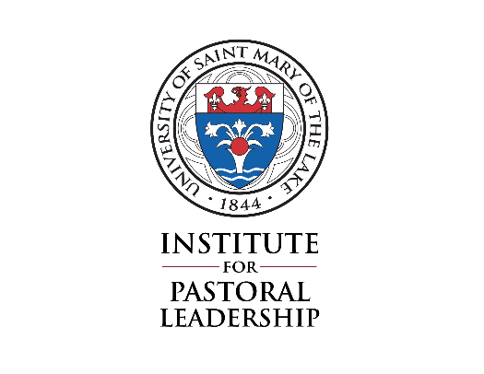
Lay Ecclesial Ministry and MAPS Programs
Spiritual Direction Annual Agreement
Academic Year 2023-2024
You are expected to meet with your Spiritual Director every 4 to 6 weeks.

Student’s Name (Please Print): ___________________________________________________________________

Spiritual Director’s Name (Please Print): _________________________________________________________

Spiritual Director’s Address: _____________________________________________________________________
_____________________________________________________________________________________________________

Spiritual Director’s Phone Number: ( _________) ______________________________________________

Email: ______________________________________________ Fax: ________________________________________

Director’s Signature: _______________________________________________ Date: ______/______/_______

Directee’s Signature: _______________________________________________ Date: ______/______/_______

Please return this form by October 1, 2023:
Institute for Pastoral Leadership
Attn: Dave Retseck, Associate Director
University of Saint Mary of the Lake
1000 E. Maple Ave. Mundelein IL 60060-1174
Phone: 847.837.4553 FAX: 847.837.4565
Email: dretseck@usml.edu

