

Emergency Alerting System (EAS) Setup
Directions for installing and using InformaCast

Overview
The InformaCast Emergency Alerting System (EAS) is a cloud based emergency alerting platform that delivers messages quickly through a variety of delivery methods. The best and quickest way to reach on and off campus students, faculty, and staff is through the app and we encourage everyone to install it. It also sends alerts to email, on campus phones and computers, cell phones via text and an app with text, audio and video, allows users to respond to let you know if they need further assistance, has National Weather Service alerts built in, can alert campus guests for a specified number of days, can integrate into emergency phone poles, and will monitor and record 911 calls. It is used by Illinois State University, College of Lake County, the University of Kentucky, and many additional universities.

Installing the App

Apple iOS
Click on https://itunes.apple.com/us/app/informacast-mobile/id691285264?mt=8 from your Apple phone or tablet and install the app. Alternatively you can go to App Store and search for “InformaCast Mobile”.

Android
Click on https://play.google.com/store/apps/details?id=com.singlewire.cirrus from your Android phone or tablet and install the app. Alternatively you can go to Play Store and search for “InformaCast Mobile”.

Opening the App and Logging In
When you first open the app, you will see the log in screen. Tap Log In. | When logging in you will use your USML email address. | Enter your email address and password. The password will be the same as your other USML services. | You will initially see No Notifications.
 | 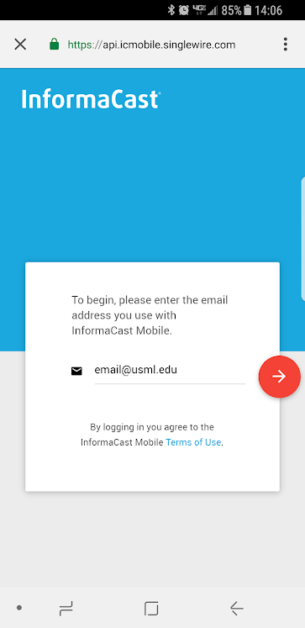 | 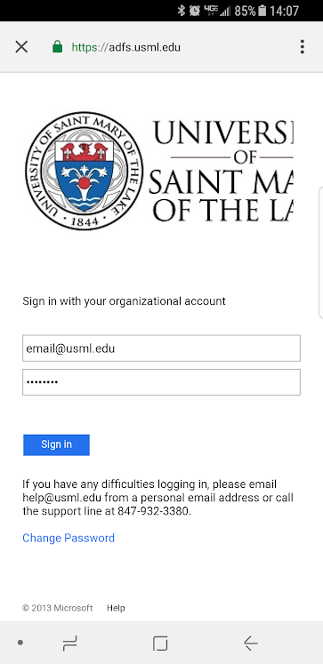 | 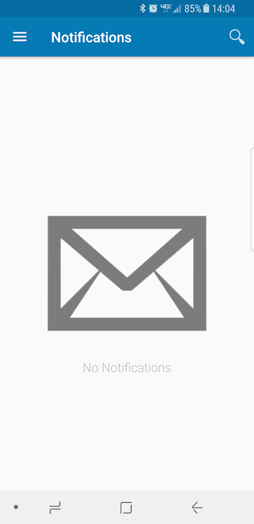
If you have already given USML your cell number you should be pre-configured. Please tap on the triple bar on the upper right-hand side and go to Self Service to confirm. | If you do not see a SMS number please fill it in with your cell number. You can also fill this in if you would like to receive alerts, but not publish your cell number. | When an alert comes in, it will include text and/or audio and may ask for confirmation. | In the event of an actual emergency, please follow all instructions and respond to all messages if asked to do so.
 | 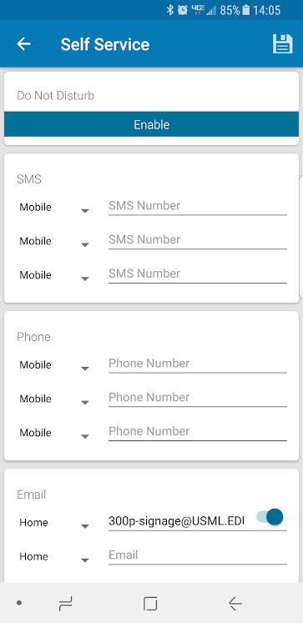 | 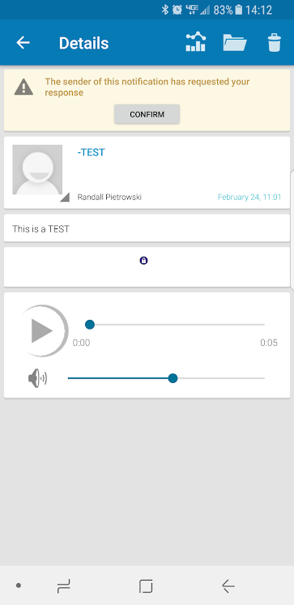 | 