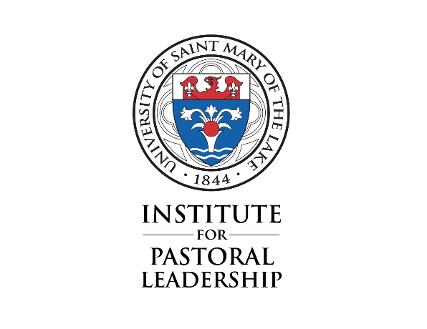
University of Saint Mary of the Lake
Catechetical Coordinator Program
Ministerial practicum
Student Evaluation

The Supervisor will complete this mid-year Student Evaluation form
midway through the practicum (date to be determined by Supervisor and student).

Student Name: _____________________________________________________________________________

Supervisor Name: __________________________________________________________________________

Site Placement: _____________________________________________________________________________

Please indicate the primary focus for ministry preparation:
General catechetical (CRE): ____________________________
Adult faith formation (CAFF): __________________________
Youth ministry (CYM): __________________________________

- Please rate the student’s progress in terms of carrying out his/her Learning Plan.
  - Excellent
  - Very Good
  - Good
  - Needs improvement

Please explain why you gave the student this rating:

- After several weeks of working with this student, do you see any need to modify or change his/her Learning Plan for this Ministerial Practicum? Please explain.

- How many hours has the student worked per week since beginning this Ministerial Practicum? Are there any reasons to change the work schedule?

- What are the strengths of this student in terms of his or her engagement with:
  - The people being served

  - The content of the program

  - Pastor and parish staff

- What are the challenges for this student in terms of his or her engagement with:
  - The people being served, or particular situations

  - The content of the program

  - Pastor and parish staff

Recommendations:

Please sign below:

Student _______________________________________________________ Date: _______________________

Supervisor ___________________________________________________ Date: _______________________

Rev. June 29, 2020

