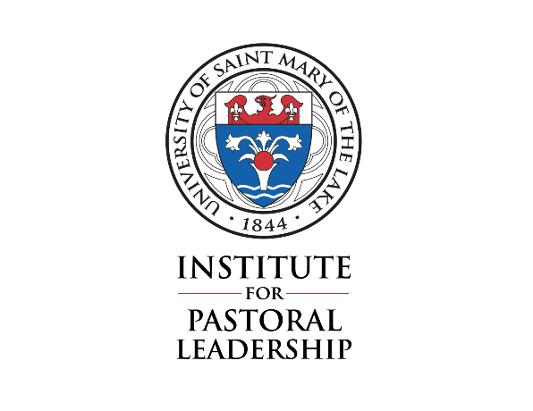
University of Saint Mary of the Lake
Catechetical Coordinator Program
Ministerial practicum
Requirements

A supervised Ministerial Practicum is a required component of the Catechetical Coordinator (CC) Program, which leads to certification as a Coordinator of Religious Education (CRE), Coordinator of Adult Faith Formation (CAFF), or Coordinator of Youth Ministry (CYM). All the forms mentioned below can be found on our website https://usml.edu/ipl/cc/. The completed forms will become part of the student’s file at the Institute for Pastoral Leadership (IPL).

Here is a brief description of each requirement* of the CC Ministerial Practicum:

- Ministerial Practicum site. Each student will select a site where s/he will exercise the Ministerial Practicum. Please use the Basic Site Information form to capture information about the site, Supervisor, and ministry leadership role. This completed form is due no later than October 30th.

- Supervisor. The Supervisor should ideally be on-site and able to observe the student during their practicum experience. He or she is someone who has responsibility and oversight for the particular ministerial work, and is a member of the staff of the parish or institution.

If the Supervisor is not on-site, the student would need to meet regularly with the Supervisor to share their plans, preparations, and programs, and for the advice and recommendations of the Supervisor. The off-site Supervisor will need to plan adequate opportunities to observe the student in his/her ministry.

The student should plan to meet with the Supervisor once a month for a period of approximately 45 minutes between the months of October and August.

- Ministry leadership role. The role must meet the following requirements:
  - The student is directly responsible for a particular ministry that includes areas such as recruiting, leading, and forming volunteers. This role should be related to the area of desired certification. For example, a CRE should be in a general catechetical role, a CAFF should be in an adult faith formation role, and a CYM should be in a youth ministry role.
  - The ministry leadership role consists of about 6 working hours per week (paid or unpaid), which includes preparation time for the area of responsibility. Preparing a presentation, scheduling volunteers, and collecting information would be considered preparation time.
  - The role has a specific ministry description which is composed by the student together with his/her Supervisor. This description is included on the Basic Site Information form.
  - The Supervisor reports directly to the Associate Director of the IPL as to the student’s evaluation and progress.
  - If it is difficult to find a Supervisor for your ministry site, please resolve this issue with the assistance of the Associate Director of the IPL.

- Learning Plan. The student must develop a Learning Plan together with their Supervisor. This plan is meant to help the student identify the learning goals and objectives for the practicum. It will include a schedule of the student’s practicum in terms of times, dates, hours, etc. It will also help the Supervisor to focus on the necessary outcomes of the practicum. The Learning Plan form is due no later than October 30th.

- Student Evaluation. The Supervisor will complete a mid-year Student Evaluation form midway through the practicum (date to be determined by the Supervisor and student).

- Complete a total of 300 hours. The 300 hours of ministry are equivalent to about 6 hours a week over one-two calendar year. The record of hours is included in the Final Evaluation form.

- Final Evaluation. The student and the Supervisor will meet to review the entire ministerial experience, the record of hours, and complete the Final Evaluation form. This form is to be submitted to the IPL as soon as the practicum is complete.

Please submit all completed forms to the Associate Director of the Institute for Pastoral Leadership so that they can be reviewed and included in the student’s file. Thank you.

* These requirements and the related forms were adapted from the Lay Ecclesial Ministry Program document, Ministerial Practicum Requirements, and other Lay Ecclesial Ministry forms by Catherine Sims.

Rev. June 29, 2020

