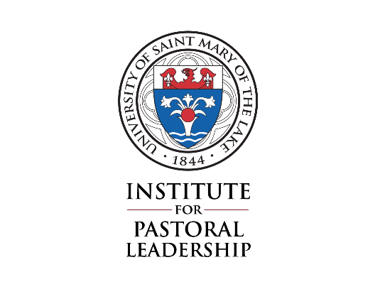
University of Saint Mary of the Lake
Catechetical Coordinator Program
Ministerial practicum
Learning Plan

It is the responsibility of the student to develop a Learning Plan together with their Supervisor. A photocopy of this form should be given to the Supervisor.

Please complete this form and return it no later than October 30th to: Michelle Shaffer
Institute for Pastoral Leadership
University of St. Mary of the Lake
1000 East Maple Avenue
Mundelein, IL 60060
Date: _____________________
Student’s name: _________________________________________________________________
Ministerial Practicum site: ______________________________________________________
Supervisor’s name: ______________________________________________________________

CALENDAR: In this section, please provide the specifics of the Ministerial Practicum calendar. Please note: travel, including travel hours, does not count as part of the practicum experience.

Beginning Dates: Ending Dates:
Fall _____________________________ _________________________
Spring __________________________ _________________________

Weekly schedule: [day, time(s), frequency, etc.]

Any breaks, vacations, etc. when you will not be engaging in the practicum:

Monthly supervision schedule:

Preparation time:

Other:

Total number of hours planned for each week: ___________________

To be filled out by the student in consultation with the Supervisor:

- Student’s Outcomes (Learning Goals): List three ministerial learning outcomes (goals) you seek to accomplish at this site.

- Ministerial Activities: For each learning outcome (goal), identify a specific task, responsibilities and/or strategies that will enable you to achieve that goal.

- Competencies: List three practical ministerial skills you need to develop through this Ministerial Practicum that will help you develop as a Catechetical Coordinator. Explain how you will develop these skills through this experience.

- Human Formation Development: List three goals in the area of human formation on which you will focus during this Ministerial Practicum.

- Pastoral Formation Development: List three goals in the area of pastoral formation on which you will focus during this Ministerial Practicum.

To be completed by the Supervisor alone.

- Supervision Assessment: For each outcome named by the student, identify the format for supervision, the frequency of supervisory contact and the means of assessing the student’s achievement of the stated goal.

- Outcomes: Please identify the pastoral responsibilities you expect the student to perform/experience during this Ministerial Practicum.

- Competencies: Please identify how you will assist this student in his/her formation, realization of learning goals outlined above, as well as achieving the competencies needed.

Student Agreement: As a student in the Catechetical Coordinator Program, I commit to the following actions:
- Attend any site orientation or training needed in order to carry out my practicum.
- Complete my scheduled hours and responsibilities unless otherwise arranged with my site Supervisor.
- Contact the IPL Associate Director if, for some reason, I am unable to complete my normal scheduled responsibilities.
- Complete all required paperwork and assignments related to this Ministerial practicum, including consulting with my site Supervisor in the development of my learning goals.
- Be in regular communication with my site Supervisor as to any concerns, issues, etc. I am having in my practicum.
- Be prepared and engaged in my monthly on-site supervision meetings.
- Actively prepare and engage in my evaluations with my Supervisor.

Supervisor Agreement: As a partner with the Institute for Pastoral Leadership of the University of Saint Mary of the Lake, I agree to:
- Set aside a monthly supervisory session of 45 minutes. The student’s learning is the major focus of these sessions; especially those learning goals described in this Learning Plan; the student’s development in dealing with critical or challenging incidents; and his or her personal growth both humanly and vocationally.
- Work directly with the student and make explicit arrangements with the student regarding expectations, hours, duties and overall objectives.
- Provide input and direction in the development of the student’s learning goals, and review and approve them at the start of the year.
- Provide a supportive learning environment for the student.
- Maintain contact with the Associate Director of the Institute for Pastoral Leadership and provide feedback on student performance as requested or as needed.
- Complete all evaluations of the student’s performance during the course of their practicum, discuss my evaluations with the student, and then submit them to the IPL.

Signatures:

Student Signature ___________________________________________________________ Date __________________________

Supervisor Signature _______________________________________________________ Date __________________________

Rev. June 29, 2020

