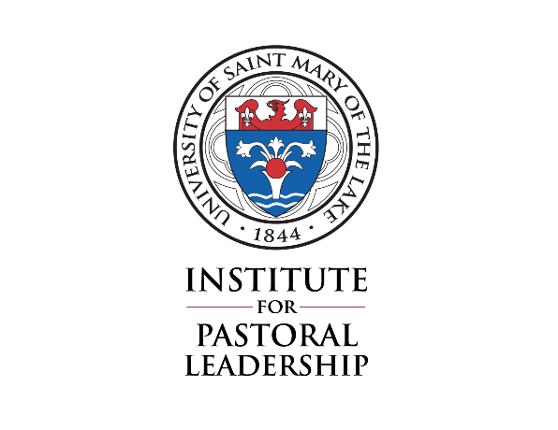
University of Saint Mary of the Lake
Catechetical Coordinator Program
Ministerial practicum
Final Evaluation

This form is to be completed individually by the student and the Supervisor. Once completed by each person, the student and Supervisor meet to discuss their responses. The student and Supervisor sign both evaluations following the discussion. Once discussed and signed, each person returns their evaluation to the Institute for Pastoral Leadership.

Please complete this form and return it no later than _________ 30th to: Michelle Shaffer
Institute for Pastoral Leadership
University of St. Mary of the Lake
1000 East Maple Avenue
Mundelein, IL 60060
Date: __________________________
Name of person completing this evaluation: ________________________________________________________________

_______ Student ______ Supervisor

Ministerial practicum site: ______________________________________________________

Record of Ministerial Practicum hours: Total hours = ________________________
August: ________________ November: ______________ February: ______________
September: ____________ December: ______________ March: _________________
October: _______________ January: _________________ April: ___________________

- Please evaluate the student’s performance by commenting on the following questions:
  - How would you describe the student’s growth over the year in terms of their identified learning goals? Please state the learning goal (as given in his/her Learning Plan) and respond to each one.

  - How would you describe the student’s growth over the year in these areas?:
    - Professional skills

    - Personal human development

    - Theological/Ethical reflection and application

    - Spiritual practice

- How well did the student perform in the parish/community context? Name any particularly noteworthy accomplishments, or areas of concern that arose during the year. Also, please include any feedback you received from parishioners or parish staff members.

- Please comment on the student’s vocational identity as a lay minister, and your assessment of his/her future leadership potential in the area of church ministry.

- In what areas do you think the student needs help or guidance moving forward?

- Please answer the following:
  - How many supervised Ministerial Practicum hours did the student spend this year?

  - How often did the student and Supervisor meet over the course of the year?

  - As student – do you intend to continue in ministry at this site in the future?
If no – why?

As Supervisor – do you recommend this student continuing in ministry at your site in the future?
If no, why?

- Summary of the Supervisor/student discussion of the final evaluation.

Please check the appropriate statement:

______ As student: I have discussed this evaluation with my Supervisor.

______ As Supervisor: I have discussed this evaluation with the ministerial student.

Signature ____________________________________________________________ Date _________________

Rev. June 29, 2020

