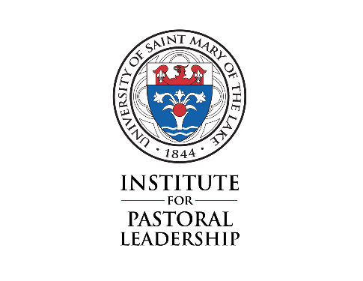
University of Saint Mary of the Lake
Catechetical Coordinator Program
Ministerial practicum
Basic Site Information

It is the responsibility of the student to choose a site for their supervised Ministerial Practicum experience, to meet with their Supervisor, and to complete this form. A copy of this form should be given to the Supervisor.

Please complete this form and return it no later than October 30th to: Michelle Shaffer
Institute for Pastoral Leadership
University of St. Mary of the Lake
1000 East Maple Avenue
Mundelein, IL 60060
Date: _____________________
Student’s name: _________________________________________________________________
Student’s email address: ________________________________________________________
Student’s phone: ____________________________________

Ministerial Practicum site: ______________________________________________________
Address for site: __________________________________________________________________
Phone # for site: ____________________________________

Supervisor’s name: ______________________________________________________________
Supervisor’s role/position: _____________________________________________________
Supervisor’s email address: ____________________________________________________
Supervisor’s phone: _________________________________

Brief description of the ministry leadership role the student will be fulfilling:
____________________________________________________________________________________________________________________________________________________________________________________________________________________________________________________________________________________________________________________________________________________________________________________________________________________________________________________________________________________________________________________________________________________________________________________________________________________________________________________________________________________________________________

Beginning date of practicum: ______________________ Ending date of practicum: _________________________
Rev. June 29, 2020

