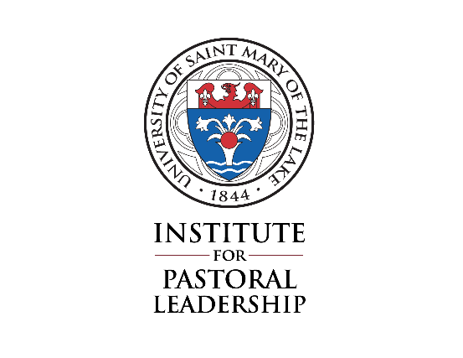
Lay Ecclesial Ministry Formation Program
Spiritual Direction End-of-Year Report

This form is to be signed and returned by April 26 of each year and becomes part of
this candidate’s record of formation. For those students who are from the Archdiocese
of Chicago, the record of their faithful participation in spiritual direction is one of the
benchmarks used for recommending the individual for Calling and Commissioning as
a Lay Ecclesial Minister.

Student’s Name:

Spiritual Director’s Name: ______________
Spiritual Director’s Address: _____________________
Spiritual Director’s Phone Number: ______________

Email: ______________ ________ Fax: ______________ _______

Spiritual Director’s Signature:

Student’s Signature:

Date of this Signing:

We have been faithfully meeting on a 4 - to 6-week basis.

I believe that our frequency of meeting needs to improve. If frequency is
an issue, how often have you been meeting? ______________

Please return this form to:
Dave Retseck
Associate Director, Institute for Pastoral Leadership
University of St. Mary of the Lake
1000 E. Maple Ave. Mundelein IL 60060-1174
Phone: 847.837.4553
Email: dretseck@usml.edu

